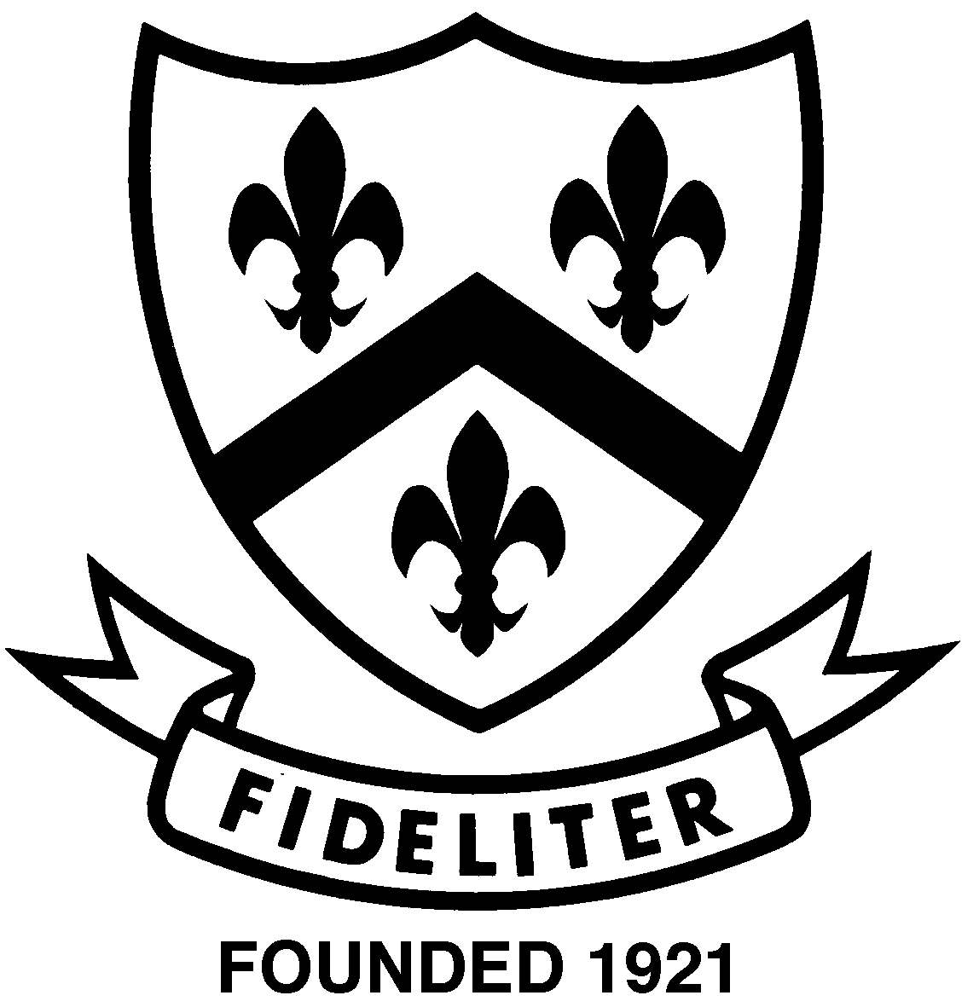
Year 12 Chemistry
Mastery Test: Distinguish between

- For each of the following pairs of substances, describe a chemical test (not the use of indicators!) that will distinguish between them. State the distinguishing observations; if there is no visible reaction write “nvr”. If there is a chemical reaction, write the appropriate equation.

 | What would you do | What would you observe | Chemical equation where appropriate
Solid Ba  and |  | With Ba
Solid Mg |  | With Mg
Solid MgO  and |  | With MgO
Solid MgCO₃ |  | With MgCO₃
(6 marks)

Year 12 Chemistry
Mastery Test: Distinguish between - SOLUTIONS

- For each of the following pairs of substances, describe a chemical test (not the use of indicators!) that will distinguish between them. State the distinguishing observations; if there is no visible reaction write “nvr”. If there is a chemical reaction, write the appropriate equation.

 | What would you do | What would you observe | Chemical equation where appropriate
Solid Ba  and | Add HCl to both and then add Na₂SO₄ solution | With Ba  A colourless odourless gas would be formed  Then a white ppt | Ba + 2H⁺ → H₂ + Ba²⁺  Ba²⁺ + SO₄²⁻ → BaSO₄(s)
Solid Mg |  | With Mg  A colourless odourless gas formed then no further change | Mg + 2H⁺ → H₂ + Mg²⁺-
Solid MgO  and | Add a solution of dilute hydrochloric acid | With MgO  The white solid would dissolve | MgO_{(s)} + 2H⁺_{(aq)} → H₂O_{(l)} + Mg²⁺_{(aq)}
Solid MgCO₃ |  | With MgCO₃  A colourless odourless gas would be formed | MgCO_{3(s)} + 2H⁺_{(aq)} → CO_{2(g)} + H₂O_{(l)} + Mg²⁺_{(aq)}
(6 marks)

